Name(s)
Date:
Block:

Target Audiences
- Who is the “target audience” of this movie? Why do you think this is the target audience?

- Who is the “target audience” is this magazine?  - What type of advertisement would you expect to find in this magazine? |  | 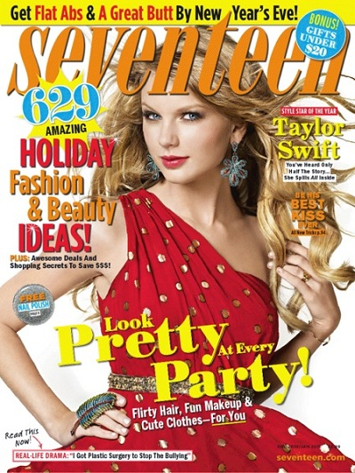
 | - Who is the “target audience” is this magazine?  - What type of advertisement would you expect to find in this magazine? | 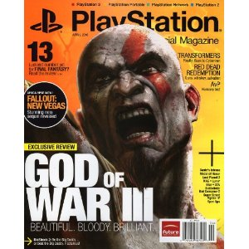
 | - Who is the “target audience” of this magazine? Why do you think this is the target audience? What are some of the clues? | *The title and the Nintendo DS are pink *
7)  Who/what is the “target audience” of this advertisement?  Why do you think this is the target audience? |  | 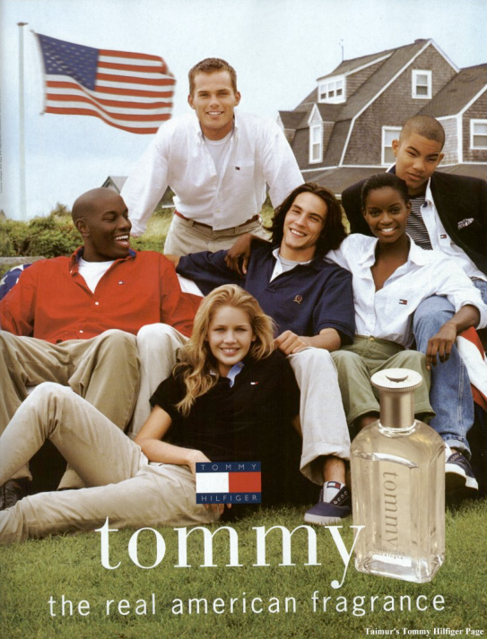
8) What time of day would expect commercials for toys to air on TV?

9) What time of day would you expect commercials for expensive luxury items like jewellery, high-end electronics and cars?

10)  Who is the “target audience” of this movie? Why do you think this is the target audience? |  | 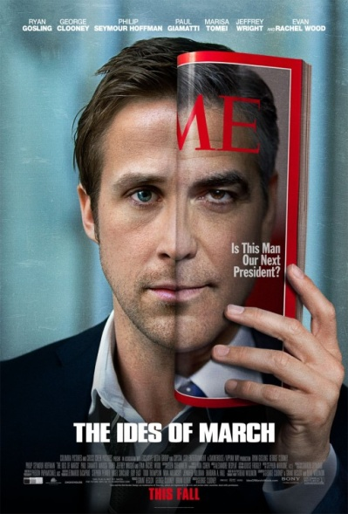
11) Based on this advertisement what is the target audience of Mac users? How are PC users depicted? |  | 